Neural networks – Running Notes

* A network without an activation function is essentially a linear regression model
* The activation function performs nonlinear transformation for the input enabling neural networks to perform more complex tasks
* Sigmoid function is an example nonlinear transformation also known as activation function they decide if neurons should be activated or not

Forward Propagation

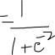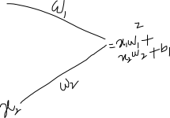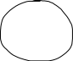

Example

* Given a neural network with a set of weights and biases, you should be able to compute the output of the network for any given input.